

**Educational Technology**

**Bangabandhu Sheikh Mujibur Rahman**

**Digital University (BDU) Bangladesh**

Course code : ICTE 4339

Course Title : Educational Web Design and Development

Assignment no : 01

Assignment on:

5 HTML Question

|  |
| --- |
| **Submitted To** |
| **Mohd. Sultan Ahammad** |
| Assistant Professor |
| Department of Computer Science and Engineering  Mawlana Bhashani Science and Technology University (MBSTU) |
|
|
|
| **Submitted By:**  Ibnul Hossain  ID: 1902008  Educational Technology |
|
|
|
|
|
| **Date of Submission:** 3rd August 2023  **All Output:**  [**https://ihtouhid29.github.io/assignment1/**](https://ihtouhid29.github.io/assignment1/) |  |

1. Create a table using HTML to show your class routine. In the table ODD row background color will be red and the EVEN row background color will be grey. Table font align should be centered. The table font color should be eye-catching.

**Github Code:**

<https://github.com/ihtouhid29/assignment1/blob/main/1routine.html>

Output:

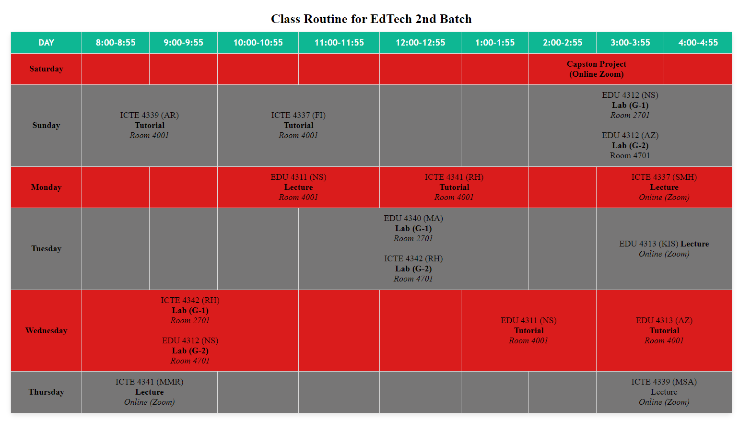

1. Use frames such that page is divided into 3 frames 20% on left to show contents of pages, 60% in center to show body of page, remaining on right to show remarks. Embed Audio and Video into your HTML web page.

**Github Code:**

<https://github.com/ihtouhid29/assignment1/blob/main/2business.html>

**Output:**

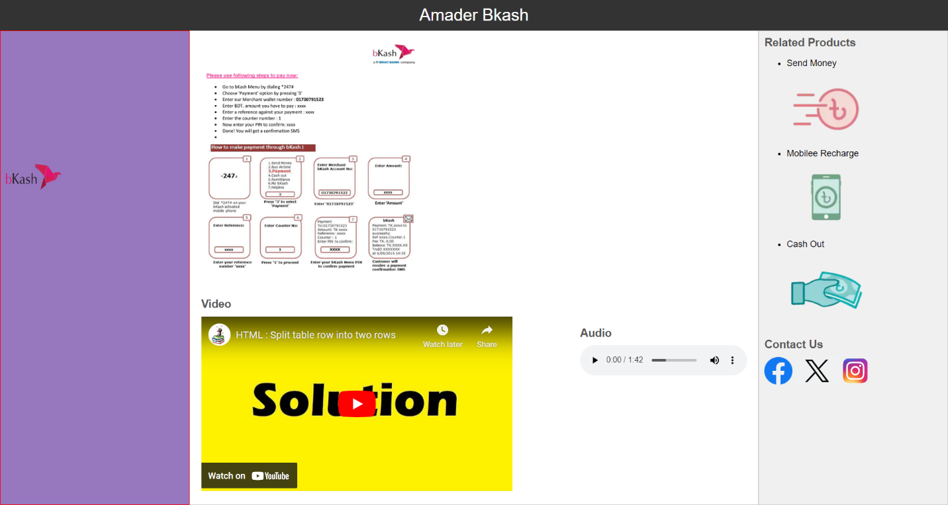

1. Write an HTML page that contains a selection box with a list of 5 countries, when the user selects a country, its capital should be printed next to the list.

**Github Code:**

<https://github.com/ihtouhid29/assignment1/blob/main/3cap.html>

**Output:**

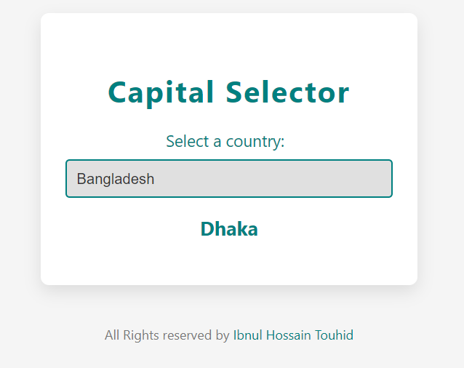

1. Create a webpage to manage personal details like name, class, qualifications, photo, address etc., using tables and other suitable HTML tags. Apply the following style information:

**Github Code:**

<https://github.com/ihtouhid29/assignment1/blob/main/4personal.html>

**Output:**

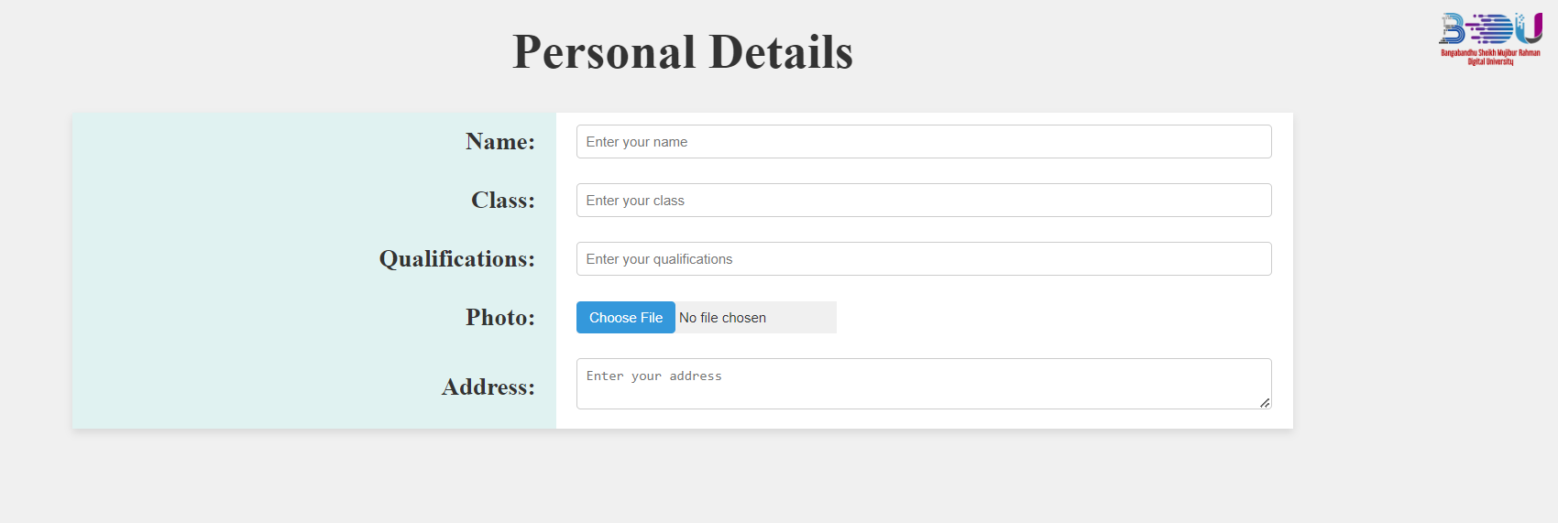

1. Create a web site for your curriculum vitae. You must use a two-column layout and the second column must be the navigation bar.

**Github Code:**

<https://github.com/ihtouhid29/assignment1/blob/main/5cv.html>

**Output:**

